LinkedIn Influence Lab
Department: Career Development & Digital Branding
Project Code: LIL-2025-P1
Priority: High
Timeline: 6 Weeks (Phase 1)
Client: [Client/Organization Name]
Prepared by: [Your Name]
Date: [Insert Date]
Version: 1.0

📑 Table of Contents
- Project Overview
- Client Background
- Business Problem Statement
- User Story
- Acceptance Criteria
- Project Objectives
- Project Tasks (Phase-wise)
- Deliverables
- Technical Requirements
- Input Information
- Evaluation Criteria
- Getting Started
- Support
- Solution Overview
- Technical Approach
- Branding & Content Strategy
- AI-Guided Workflow
- Analytics & Reporting
- Bias & Ethical Considerations
- Technical Documentation for End Users
- Quality & Acceptance Criteria
- Project Plan & Timeline
- Risks & Mitigations
- Appendices

1. Project Overview

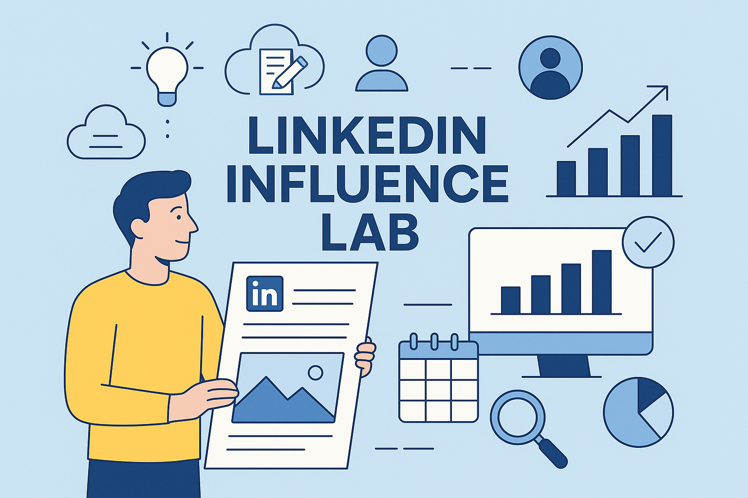

Purpose:
The LinkedIn Influence Lab is designed to help professionals build a strong personal brand on LinkedIn by combining Taplio’s content management features with ChatGPT-driven ideation and optimization.
Outcomes:
- Establish a consistent content strategy aligned with career goals.
- Build visibility through AI-assisted content creation.
- Monitor engagement metrics and refine strategy.
- Create a reproducible framework for personal branding.

2. Client Background

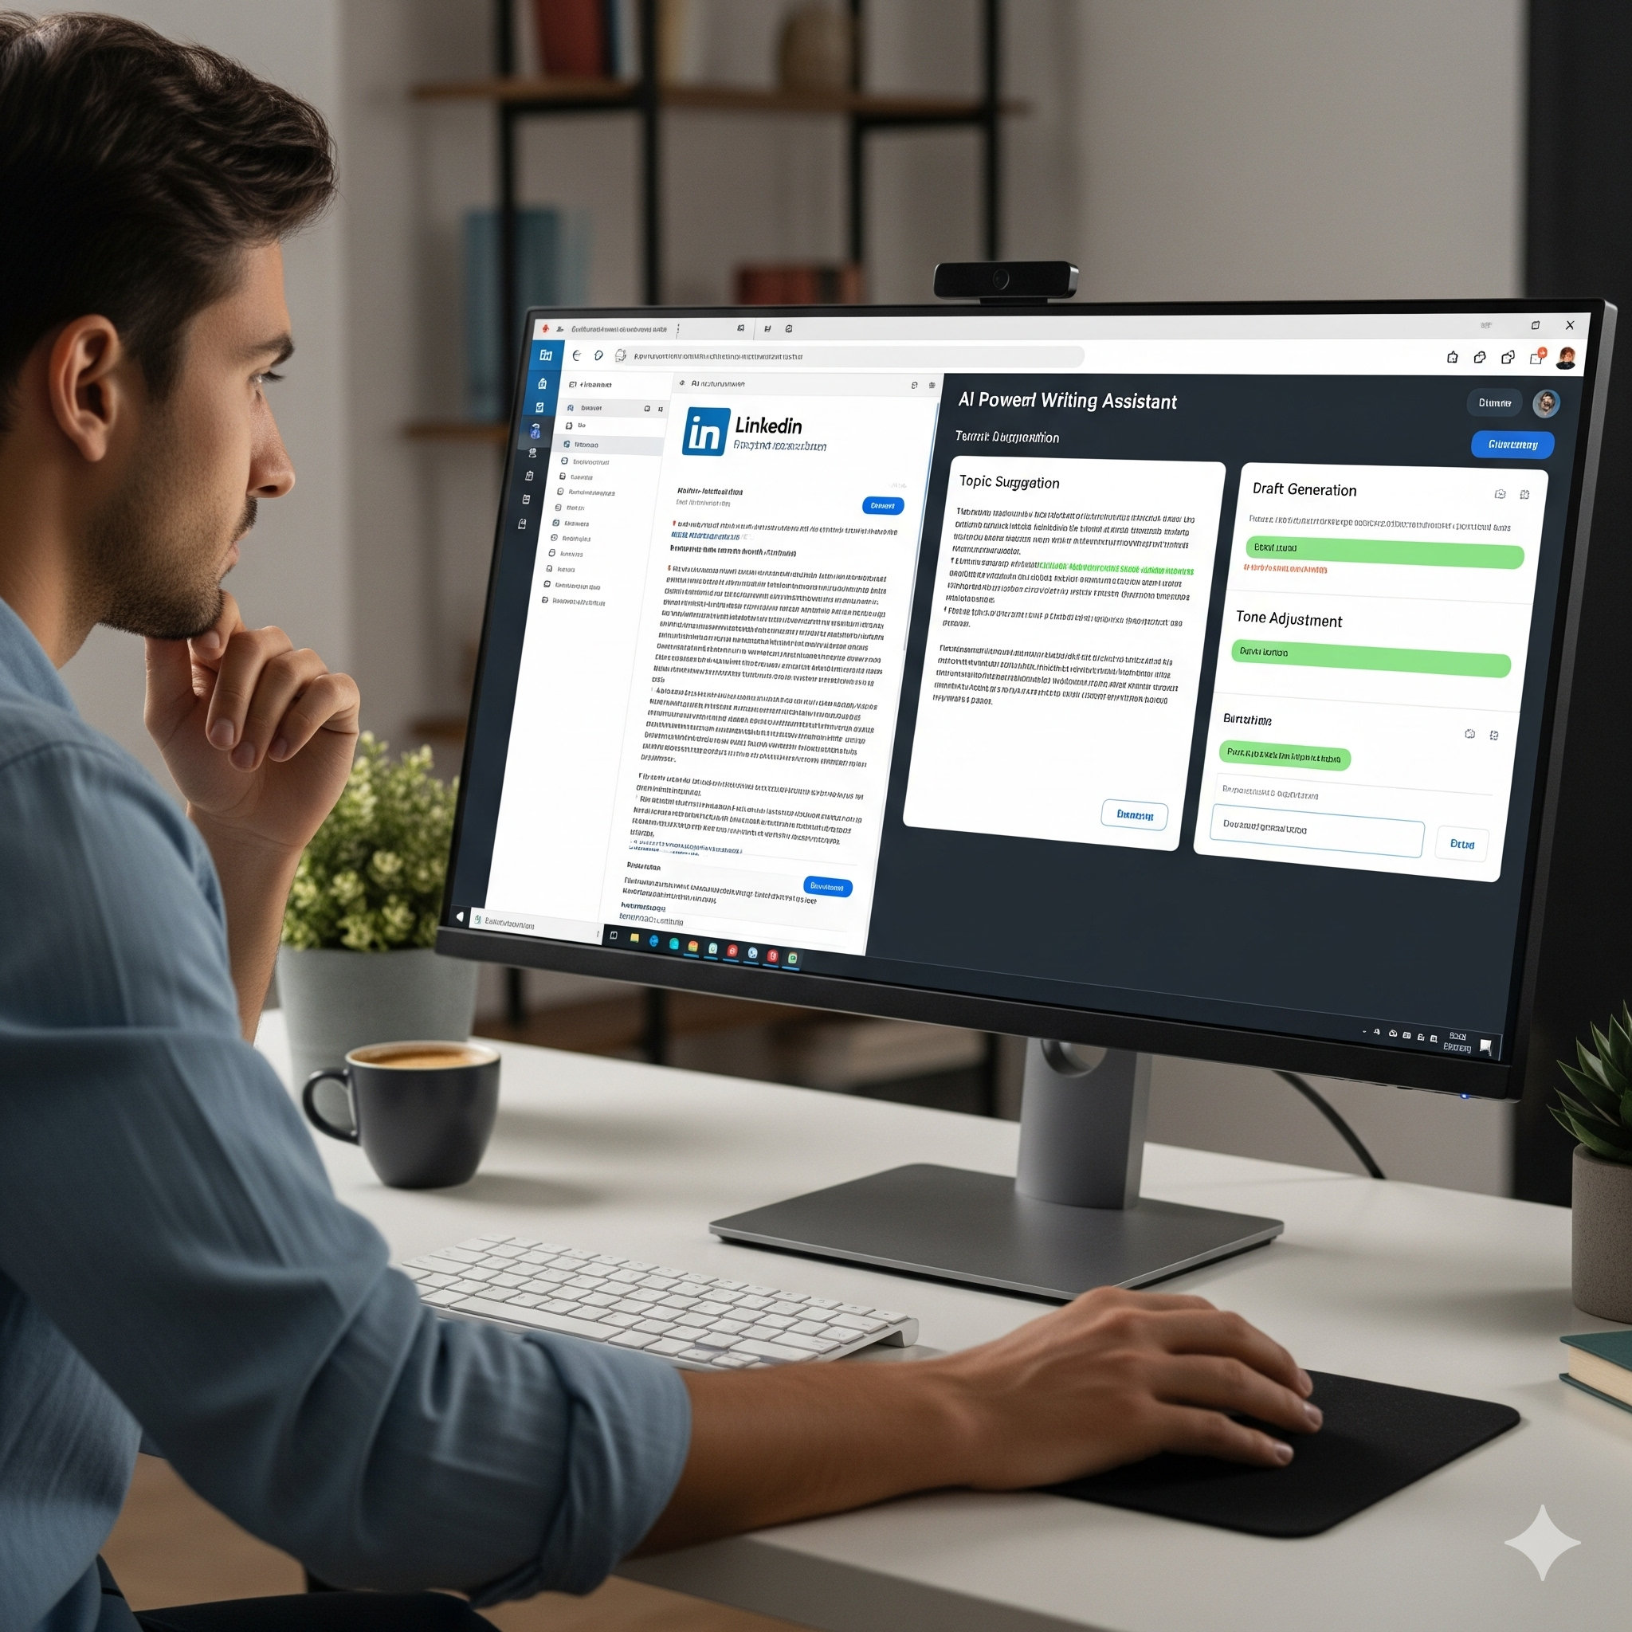
The client is an individual or organization aiming to establish or scale influence on LinkedIn.
Key Needs:
- Professional visibility in career/industry niche.
- Consistent content pipeline (posts, articles, engagement).
- Scalable system for content ideation, scheduling, and analytics.
Constraints:
- Reliance on Taplio free tier (basic features only).
- Must integrate with ChatGPT for ideation and optimization.
- Deliverables must be business-ready and reproducible.

3. Business Problem Statement
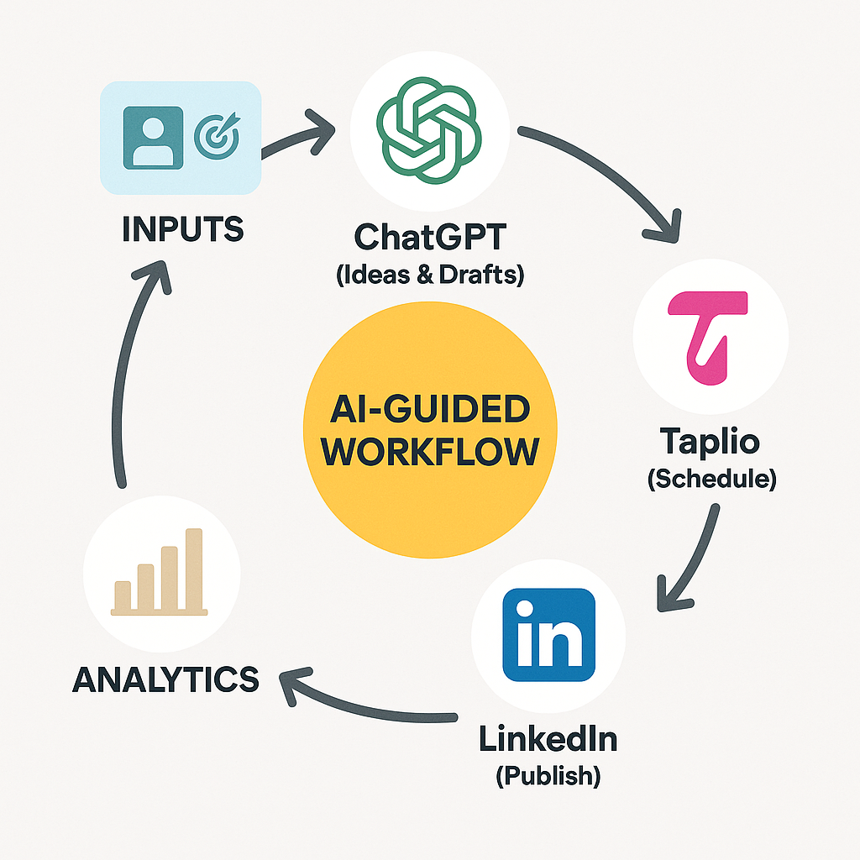
LinkedIn is the largest professional network with 1B+ users, but most professionals fail to leverage it effectively for career growth and personal branding due to:
- Inconsistent posting habits.
- Lack of strategic content planning.
- Limited time for engagement and analytics.
The solution: A structured, AI-guided personal branding lab that automates content ideation, strategy alignment, and performance monitoring.

4. User Story

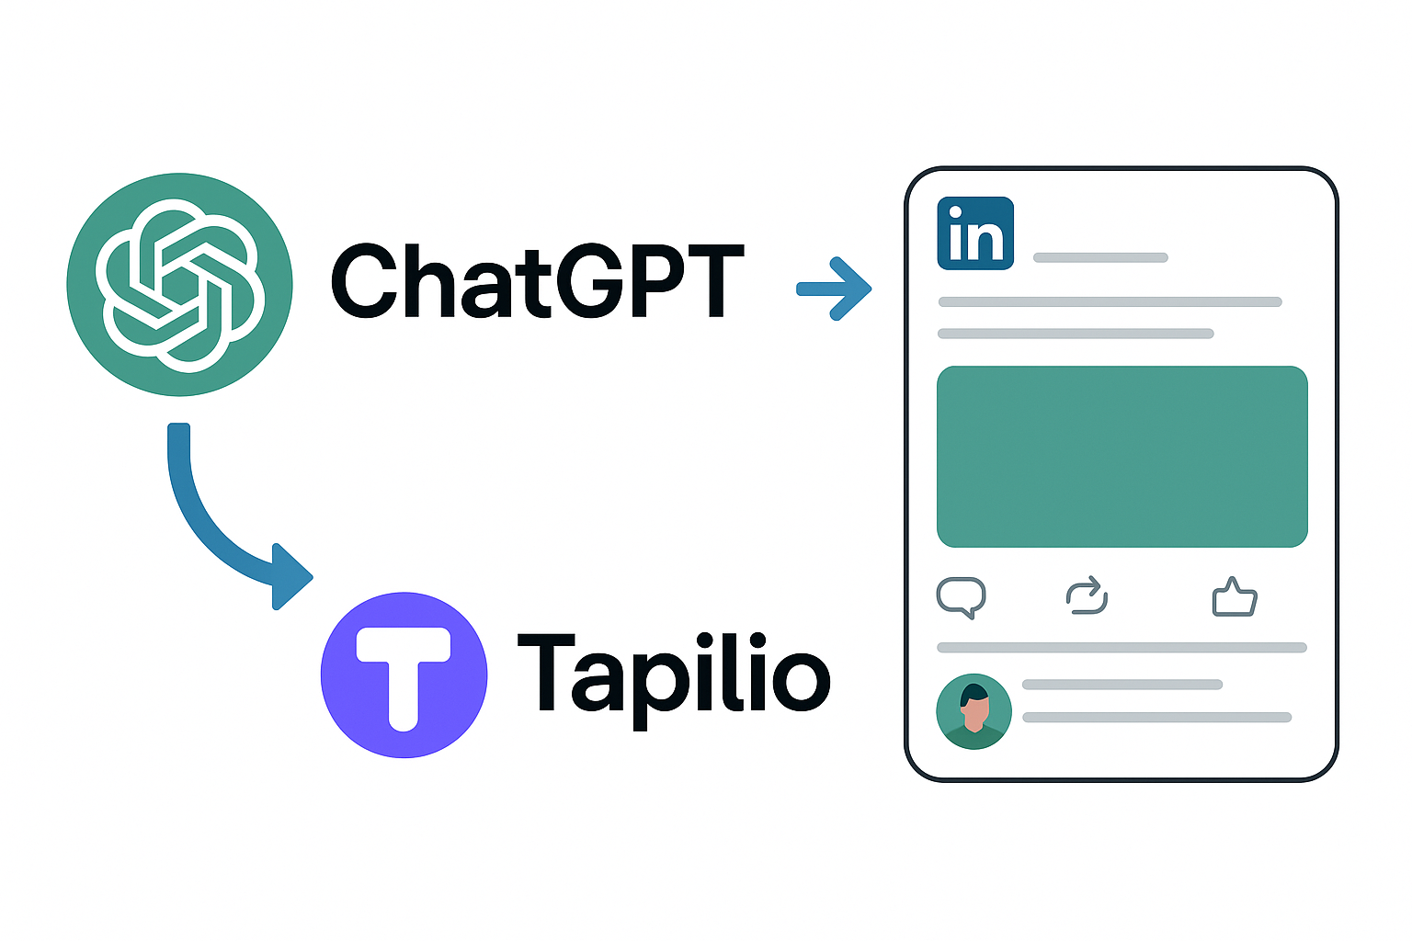
- As a professional, I want a guided content workflow so that I can post consistently and grow my personal brand.
- As a job seeker, I want to optimize my LinkedIn presence so that I attract recruiters and opportunities.
- As a thought leader/entrepreneur, I want to scale influence by using AI to generate impactful content aligned with my brand voice.

5. Acceptance Criteria
- At least 15 content ideas generated and refined through ChatGPT.
- Minimum of 10 posts published in Phase 1.
- Engagement metrics (likes, comments, shares) tracked for each post.
- Clear content calendar delivered for the next 6 weeks.
- Performance review report with improvement recommendations.

6. Project Objectives
- Create an AI-assisted content ideation workflow.
- Develop a LinkedIn content calendar aligned with career branding goals.
- Deliver optimized post drafts (engaging, concise, brand-consistent).
- Track engagement and provide actionable insights.

7. Project Tasks (Phase 1 – Branding Foundation & Content Strategy)
- Personal Branding Audit: Review client’s LinkedIn profile, current positioning, and niche.
- Content Pillar Definition: Define 3–5 core topics (e.g., career tips, industry insights, personal journey).
- AI Ideation & Drafting: Use ChatGPT to generate content ideas, hooks, and drafts.
- Taplio Setup: Configure content scheduling and engagement tracking.
- Pilot Content Deployment: Publish 2–3 test posts and track metrics.
- Content Calendar Creation: Build a 6-week posting schedule.
- Performance Review: Analyze engagement, refine strategy.

8. Deliverables
- Content Calendar (.xlsx/.csv): 6-week posting schedule with dates, themes, and draft content.
- Optimized Post Drafts (.docx): 10+ AI-assisted LinkedIn posts.
- Engagement Dashboard: Metrics of likes, comments, shares, impressions.
- Branding Audit Report: Current vs. optimized profile and positioning.
- Performance Review Report: Engagement analysis, recommendations.

9. Technical Requirements
- Tools: Taplio (free tier), ChatGPT, LinkedIn platform, Google Sheets/Excel.
- Environment: Web-based, no additional installations.
- Constraints: Taplio free tier limits (reduced analytics depth).

10. Input Information
- Client’s LinkedIn profile.
- Target audience or industry focus.
- Example role models/competitors.

11. Evaluation Criteria
- Content Quality & Relevance (30%).
- Consistency of Posting (25%).
- Engagement Growth (20%).
- Personal Branding Alignment (15%).
- Documentation & Clarity (10%).

12. Getting Started
- Perform LinkedIn profile audit.
- Define content pillars with client input.
- Generate first 5 content drafts via ChatGPT.
- Configure Taplio free account.
- Schedule pilot posts.

13. Support
Contact: [Your Name], [Email], [Slack/Teams Channel]
SLA:
- Content ideation requests: 1 business day.
- Post drafting/refinement: 2–3 days.
- Analytics reporting: Weekly.

14. Solution Overview
LinkedIn Influence Lab integrates AI content creation (ChatGPT) with Taplio’s LinkedIn workflow management to build a structured, reproducible personal branding strategy.
It provides:
- Content pipeline (ideas → drafts → scheduling).
- Engagement monitoring.
- Iterative refinement of posting strategy.

15. Technical Approach
- Content Ideation: ChatGPT generates hooks, formats, and draft posts.
- Scheduling: Taplio queues content for consistent posting.
- Analytics: Track engagement → refine posting styles.
- Feedback Loop: Optimize based on performance.

16. Branding & Content Strategy
- Content Pillars: Career insights, thought leadership, personal journey, industry trends, actionable tips.
- Content Formats: Text posts, carousels (if supported), polls, micro-stories.
- Engagement Strategy: Respond to comments, interact with industry peers, share curated content.

17. AI-Guided Workflow
- Template A: “Generate 5 engaging LinkedIn post ideas about [industry/career topic].”
- Template B: “Rewrite this draft in a professional but relatable tone.”
- Template C: “Summarize this article into a LinkedIn post with 3 key takeaways.”

18. Analytics & Reporting
- Metrics: Impressions, likes, comments, shares, profile visits.
- Dashboards: Engagement growth by week.
- Reports: Monthly summary of top-performing content.

19. Bias & Ethical Considerations
- Avoid over-automation (keep posts authentic).
- Ensure inclusivity and neutrality in language.
- Attribute sources when referencing external content.

20. Technical Documentation for End Users
- Step-by-step guide for using Taplio free tier.
- ChatGPT prompt templates.
- Example content calendar.
- Troubleshooting FAQ.

21. Quality & Acceptance Criteria
- 6-week content calendar delivered.
- ≥10 optimized LinkedIn post drafts.
- Engagement metrics tracked and documented.
- Branding audit report provided.

22. Project Plan & Timeline
Week 1: Profile audit + content pillars.
Week 2: AI ideation + pilot content deployment.
Week 3: Refine posts, finalize content calendar.
Week 4–5: Consistent posting, engagement tracking.
Week 6: Analytics review, strategy refinement, final reporting.

23. Risks & Mitigations
- Low engagement: Adjust posting time and content type.
- Free-tier limits in Taplio: Supplement with manual LinkedIn analytics.
- Over-reliance on AI: Ensure human review for authenticity.
- Consistency drop-off: Use scheduling to avoid gaps.

24. Appendices
- Prompt Templates (A–C).
- Content Calendar Sample.
- Engagement Tracking Sheet.
- Profile Optimization Checklist.

